TOTAL QUALITY MANAGEMENT

Harshavardhan Yadav

19070125527

**The 7 QC tools as defined by the American Society for Quality (ASQ) and accepted throughout the quality engineering community**

Fishbone Diagram-

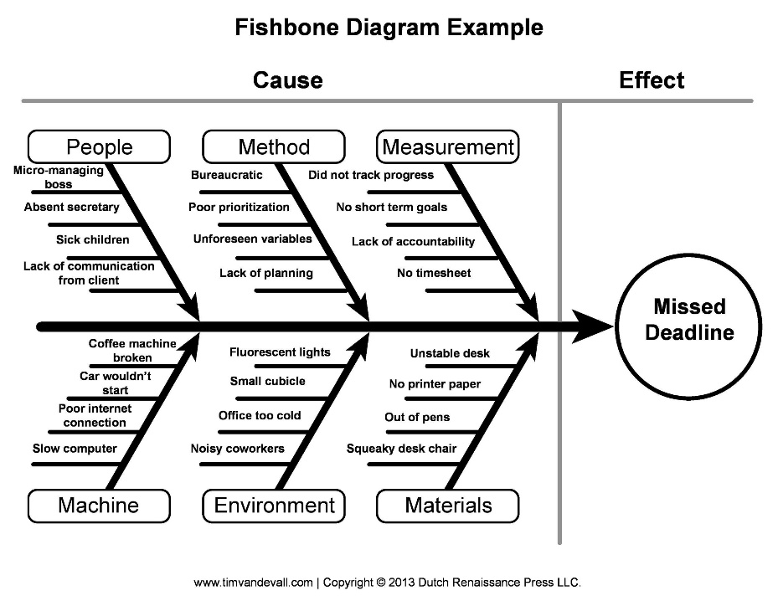

The Fishbone diagram has a certain shape which looks like a shape of a fish’s carcass

Histograms-

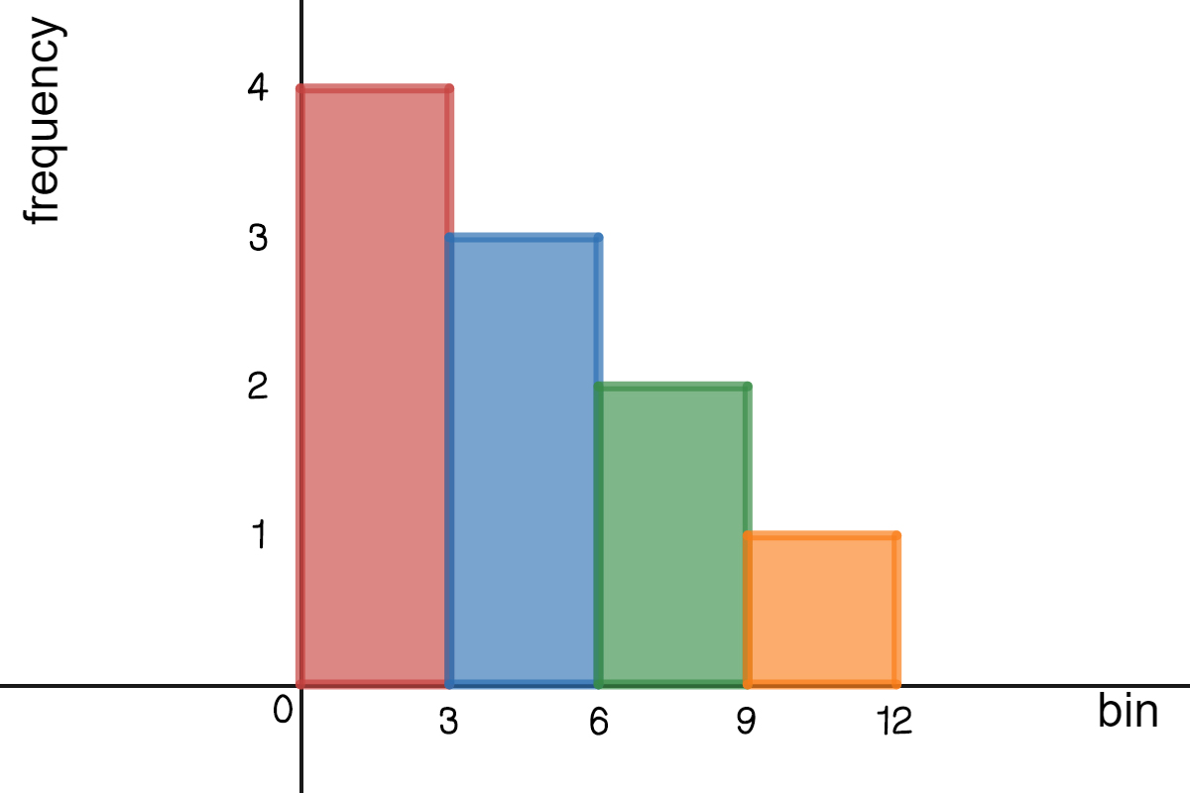

A histogram is a graphical representation of a grouped frequency distribution with continuous classes. It is an area diagram and can be defined as a set of rectangles with bases along with the intervals between class boundaries and with areas proportional to frequencies in the corresponding classes.

Control Charts-

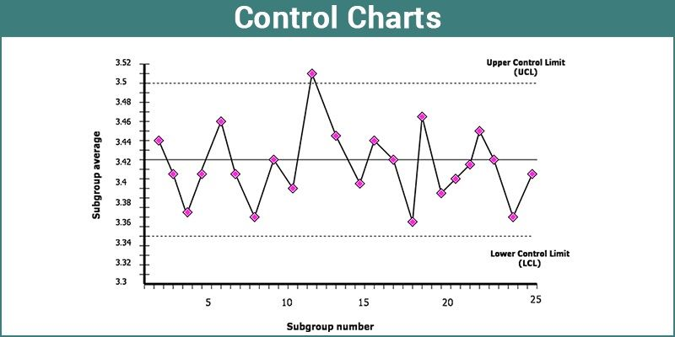

The control chart is a graph used to study how a process changes over time. Data are plotted in time order. A control chart always has a central line for the average, an upper line for the upper control limit and a lower line for the lower control limit. Lines are determined from historical data.

Scatter Diagrams-

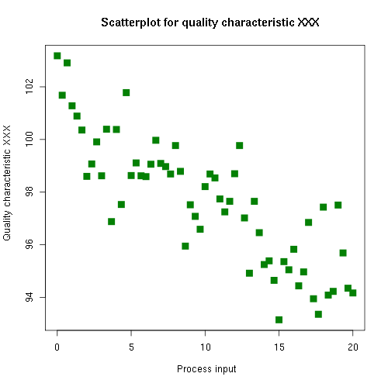

A scatter graph (also known as scatter plot, scatter diagram, and correlation chart) is a medium for analysing relationships between two given variables and also it determines how closely the two variables are related to each other.